Palantir (federated data platform training)- end to end build (speedrun) 17/12/2024

As at 17/12/2024 all NHS employees (employees with a .net account) have (limited) access to the NHS England tenancy of the national federated data platform (FDP):

https://england.federateddataplatform.nhs.uk/workspace/compass/projects

The URL above takes you to the ‘projects’ page of that platform, there you can select support and then training from the bottom left hand side of the home page:

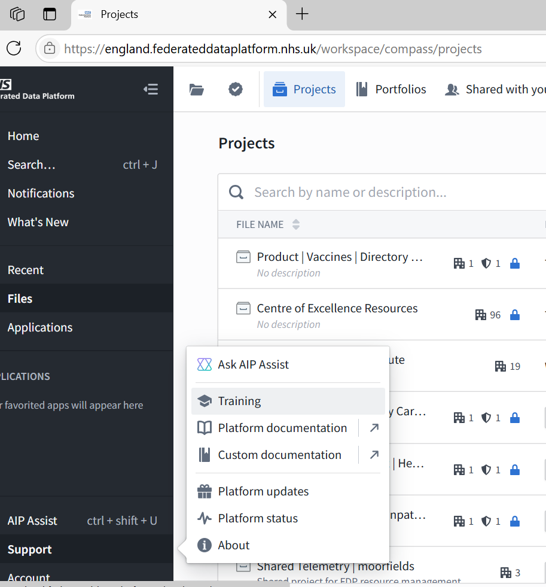

On selecting ‘training’ a number of options are available including (on the top right) the option to undertake ‘speedrun’ training (top right):

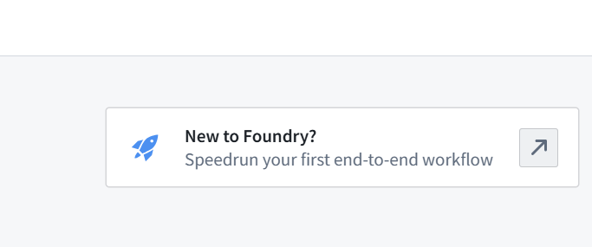

on selecting this option we are redirected to the Palantir Foundry training portal and a speedrun training exercise here:

https://learn.palantir.com/speedrun-your-first-e2e-workflow

The exercise focuses on the fictitious ‘office goods corp’ company who handle orders for stationary etc. for offices. That company has merged with another company called ‘Bureau SAS’ but unfortunately the two companies have not (yet) merged their computing systems and so it is difficult to track orders across the newly merged company and ensure that these orders are being properly tracked, allocated to staff appropriately and completed/fulfilled (which is a core aspect of this business and ensuring the business is being run correctly). Allied to this are the KPi’s for the company to track performance of the newly merged company and how it is getting on with fulfilling orders.

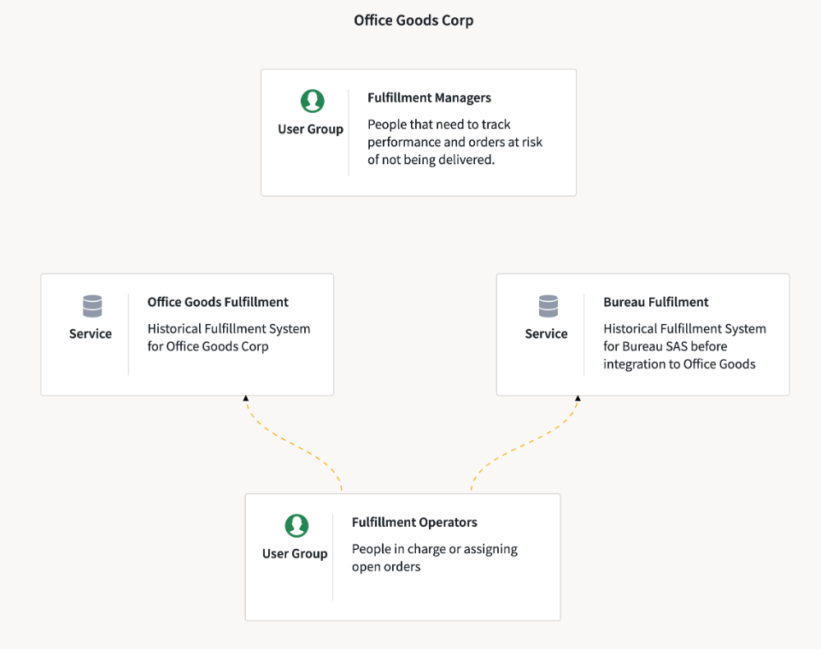
At the outset, we are recommended to set up the highest level file object in foundry (a project) within which to store the solution. The guidelines for the structure and setting up of projects are found here:

https://www.palantir.com/docs/foundry/building-pipelines/recommended-project-structure

We will discuss the recommended project structure in relation to this introductory module presently. For the purposes of this exercise a project called ‘[Learn] Palantir Training’ has been created. BUT, note that a separate instance/tenancy of the federated data platform (as at the time of writing) is being used by NHS staff upon which to complete the training namely:

https://solutionexchange.federateddataplatform.nhs.uk/workspace/compass

moreover (unfortunately) you will not have (by default) permissions to create a project, so rather than creating a project you will have to create a folder in this existing project ‘[Learn] Palantir Training’ within which to complete the project/learning, and it is suggested that you use your name (forename/surname) to name that folder:

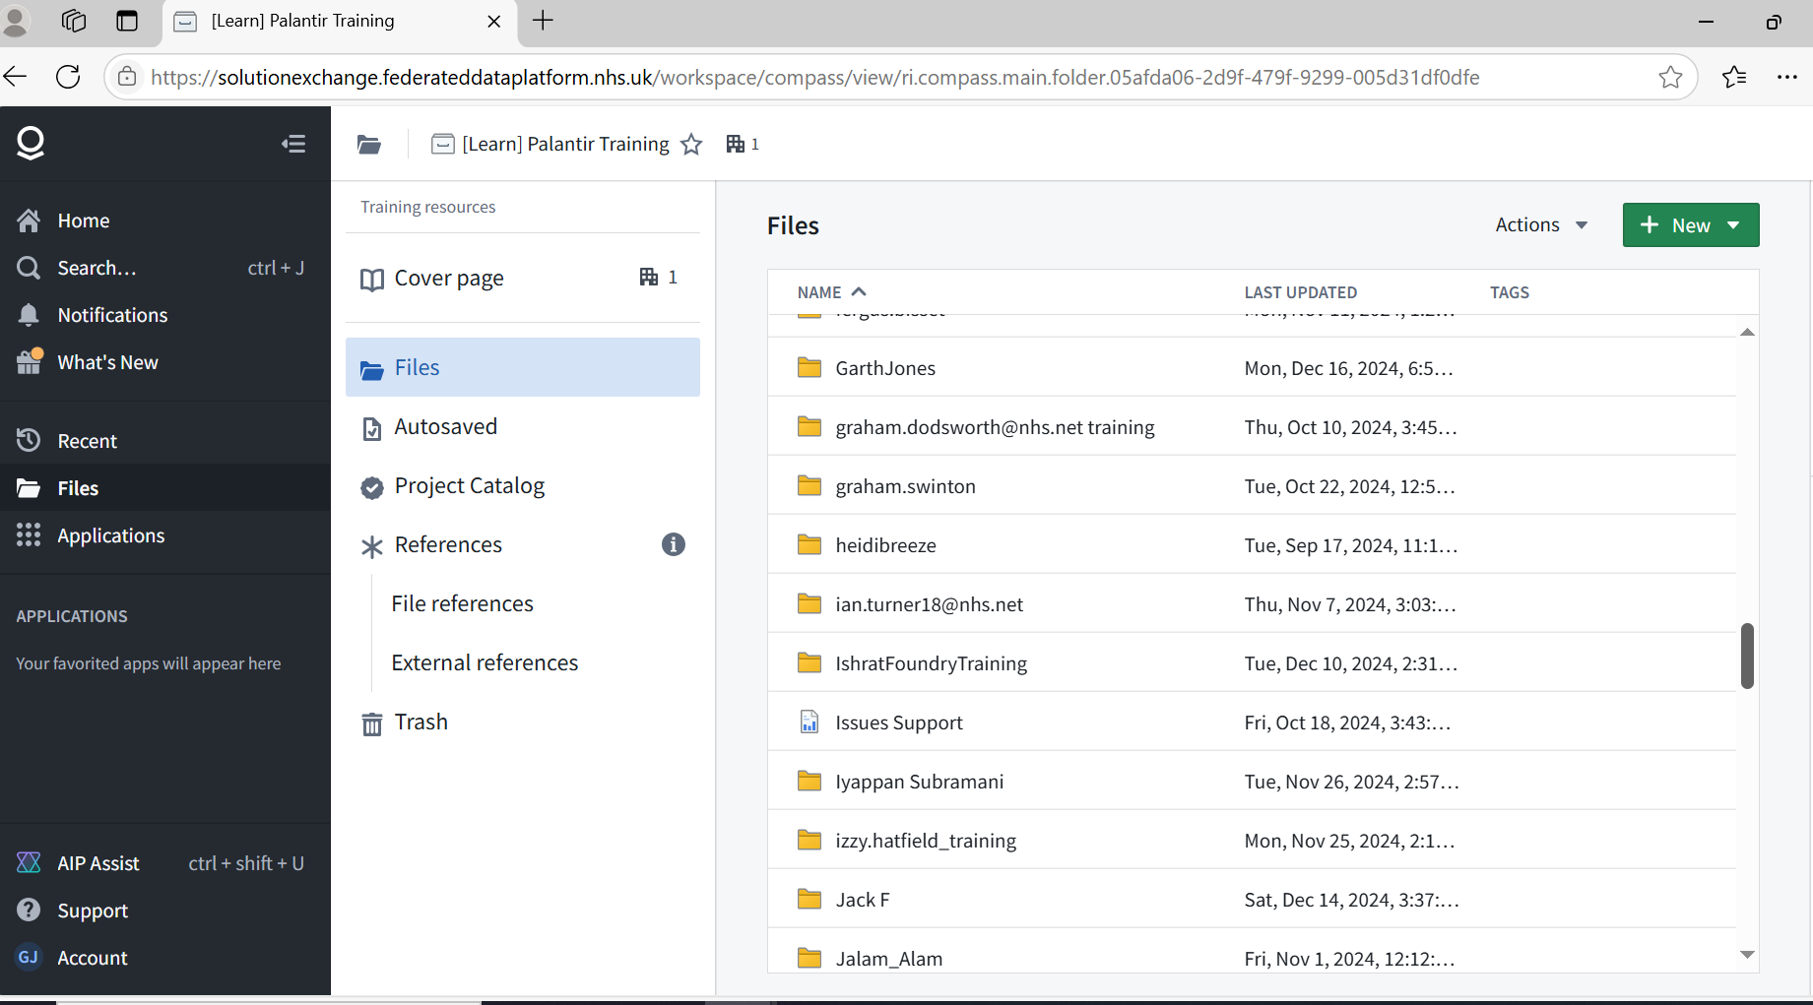

Finally,in this folder within this training project we create a another sub-folder for this specific exercise called: ‘Speedrun: Your First E2E Workflow’.

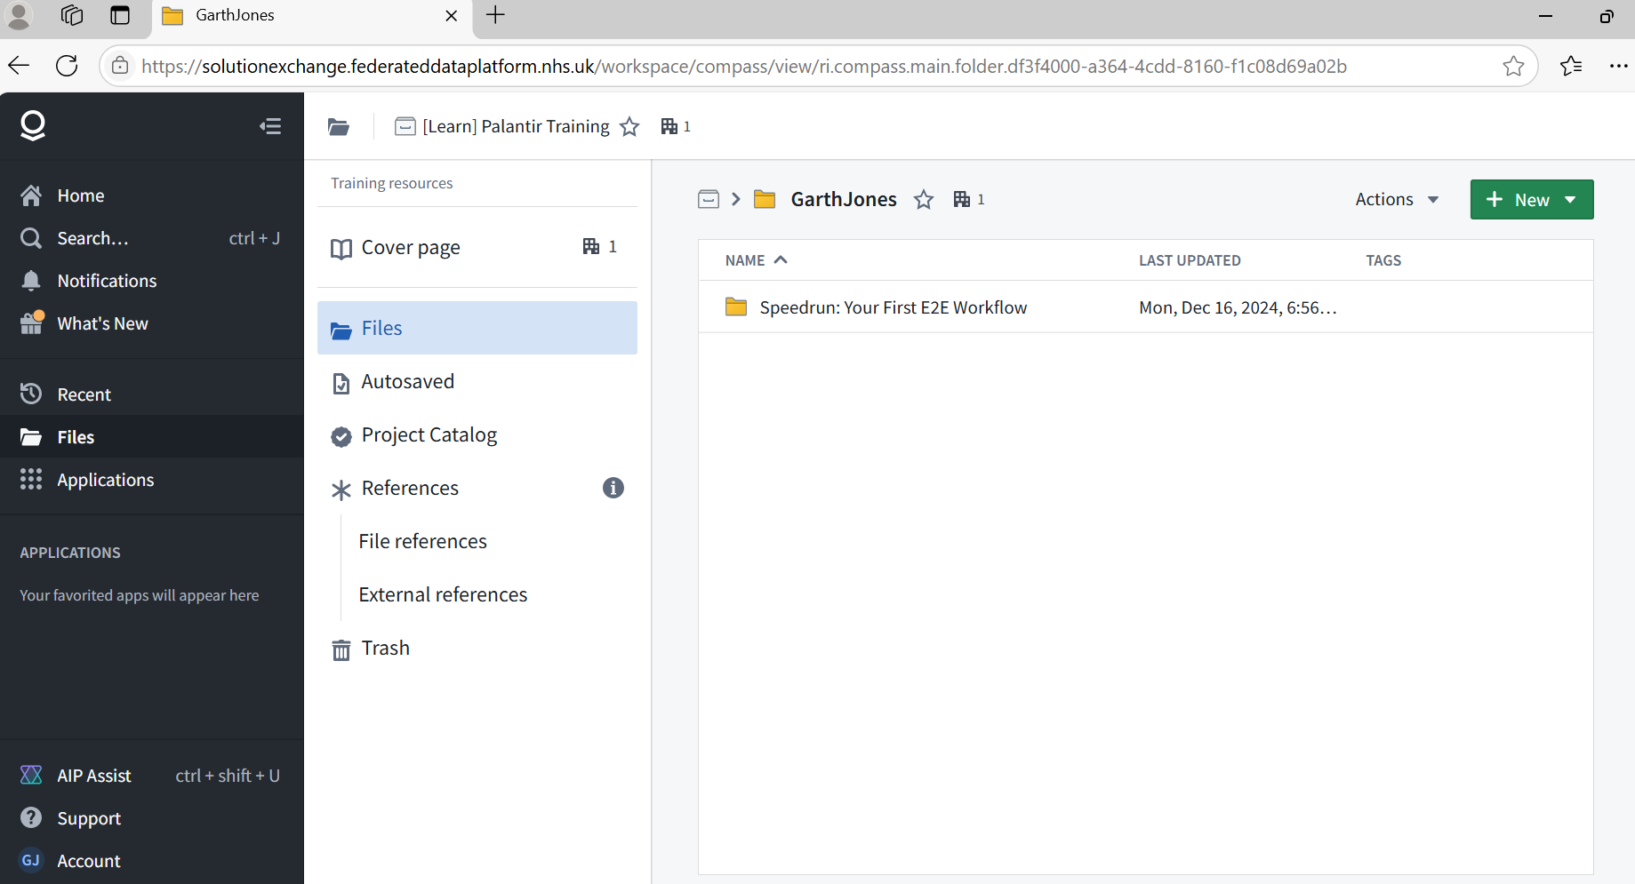

Now that the base project/folder structure is set up we need to briefly design the build in accordance with the recommended Palantir Project structures and regular (current) practice and so we set out a sketch of the system build whereby we will integrate the data for orders for office goods from the two fictitious office stationary supply companies.

I cannot stress enough that the essential structure of the following design is essentially THE build template which is used currently by Palantir engineers to build the solutions for the NHS (such as the care coordination solution and the OPTICA discharge coordination tool), we therefore need to discuss the design which in essence is split across objects created in 3 projects – an ingestion/integration project, an ontology project and a front end application project:

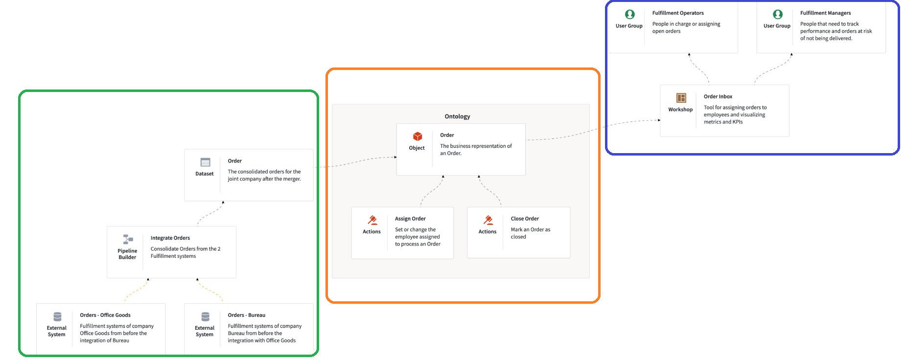
Taking each project in turn (numbered 1 to 3) and colour coded green, orange and blue respectively we can say the following about each:

- The first ‘green’ project is the data ingestion and integration layer, and here we use foundry data engineering tools such as ‘data connector’ and ‘pipeline builder’ with which to ingest the different datasets/data sources and integrate them into consolidated datasets suitable for supplying business intelligence
- The second ‘orange’ layer uses Pyspark (python) transforms to take the essential business intelligence concepts formed in the integration project at product/build layer ‘1’ and map the data items therein to what is called the ‘ontology layer’ which is also – increasingly - (now) being called the canonical data model (CDM). This is what I would call a ‘data model’ but it aims to be a little more than that in the sense of being what we might call a ‘business data model’. Thus the idea is that these ontology objects (which are fundamentally datasets adhering to a defined data definition model) become common universalized business concepts within the NHS that in principle can be used in multiple applications for the business – concepts such as clinician, patient or ward (for example) – thus each ontology object can be utilized in multiple applications and for multiple purposes as being a standard concept within a universalized data model. Note also that the structure/definition of this ontology is being maintained in a Github repository by the NHS England team see: https://www.england.nhs.uk/digitaltechnology/nhs-federated-data-platform/solution-exchange/nhs-federated-data-platform-canonical-data-model/ and https://github.com/nhsengland/fdp-canonical-data-model - note the PDF data specification specification within Github which is worth a review. Just as in the example here (for the office supplies orders system example an ontology/CDM is fundamental to the build), so too is an ontology/CDM essential to the Care Coordination System and Optica solutions which have been built in Palantir Foundry
- The third (blue) layer follows the integration and ontology/CDM) layer. That layer may be called the ‘application layer’ and you can see that a tool in Foundry called ‘workshop’ is used to build front end applications which work off the data in ontology/CDM layer – again, this is the same approach which has been used by Palantir engineers to build the solutions currently in use by the NHS.

The above represents the ‘ideal’ project structure but, as noted, unfortunately you do not have permissions to create projects and thus the ideal project structure and so for the purposes of this exercise (and as noted) in the absence of having the requisite permissions you will create folders within the existing ‘Learn’ project instead. It is worth noting the ideal structure and the Palantir Engineer conventions which have been followed to build the existing NHS solutions.

The 3 datasets for ingestion are:

- orders_office_goods.xlsx: All the orders from Office Goods Corp., the fictional company you work for
- orders_bureau_transactional_system.xlsx: All the orders from Bureau SAS, the fictional company your company bought
- consolidated_customers.xlsx: A consolidated list of customers across both fictional companies

